**Think and Answer**

**#1110**

|  |  |
| --- | --- |
| **Team leader name** | Shubham Baranwal |
| **College** | Guru Nanak Dev Engineering College |
| **Email** | shubhambaranwal83@gmail.com |
| **Date** | 26/11/2019 |

Please answer all the questions given below. You are allowed to use figures or diagrams to support your answer. Since these questions test your understanding of the whole subject, please refrain from directly asking for answers on Piazza.

**Section 1 - Simple Pendulum**

Q1) Find the eigenvalues of Simple Pendulum at equilibrium point (0,0). Is the system stable or unstable at this point? (2)

Ans.) The eigenvalues of simple pendulum at equilibrium point (0,0) is $±\sqrt{\frac{g}{l}}ⅈ$. The system is marginally stable meaning the system will be continue to oscillate about the equilibrium point indefinitely.

Q2) Can the Pendulum be balanced at an arbitrary point such as (2π/3,0) using the Pole Placement or LQR controller? Why? Why Not? Justify your answer. (3)

Ans.) Yes, it can be balanced at an arbitrary point such as (2π/3,0) using the Pole Placement or LQR controller because of the feedback control loop. We want the system to stay in that position and both Pole Placement and LQR controller provides the system with a gain and using that gain the system try to balance it and achieve a particular state using an external force.

**Section 2 - Mass Spring System**

Q3) Derive the equations of Mass Spring system. (3)

Ans.)

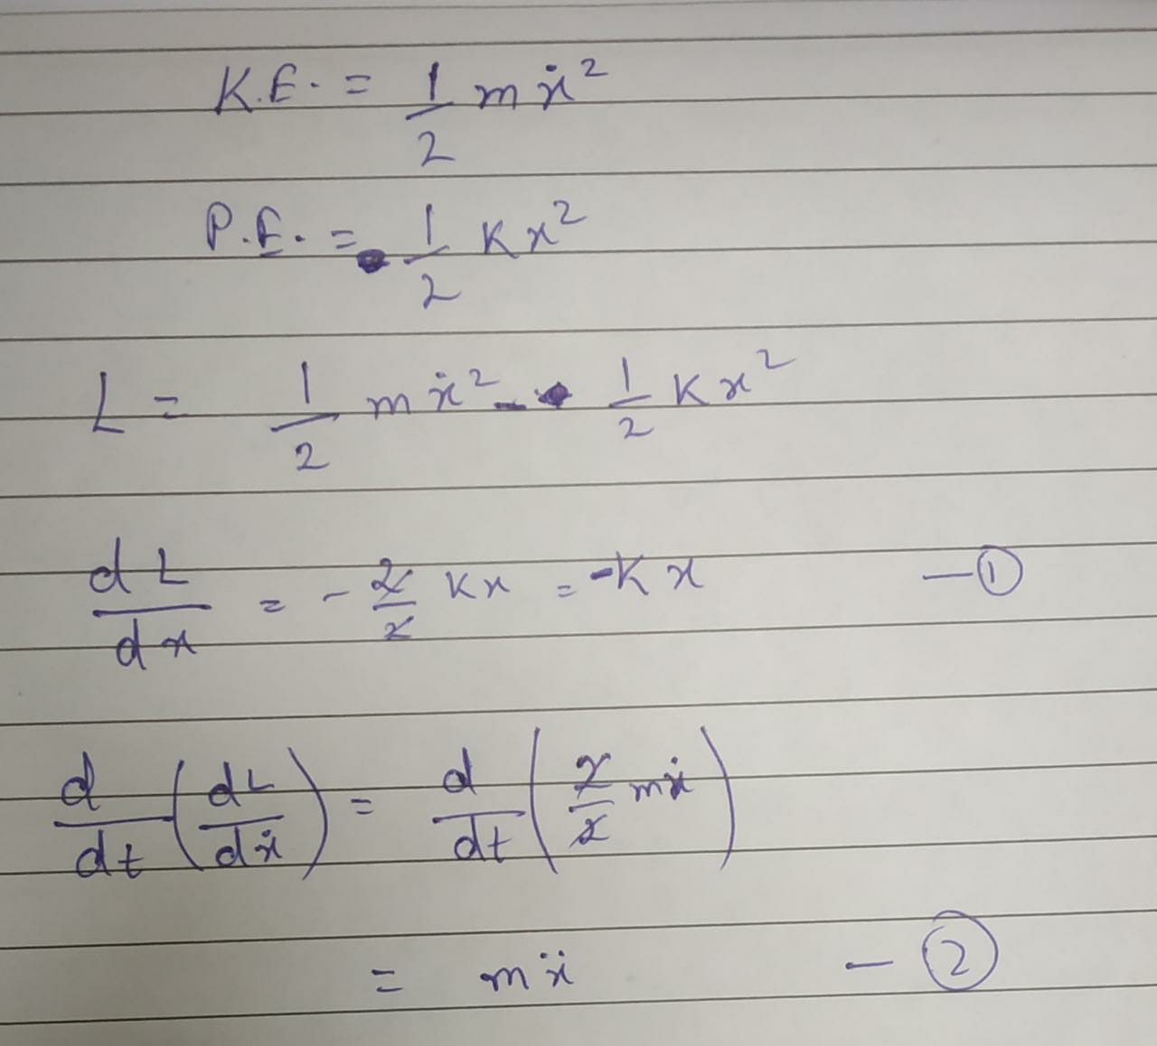

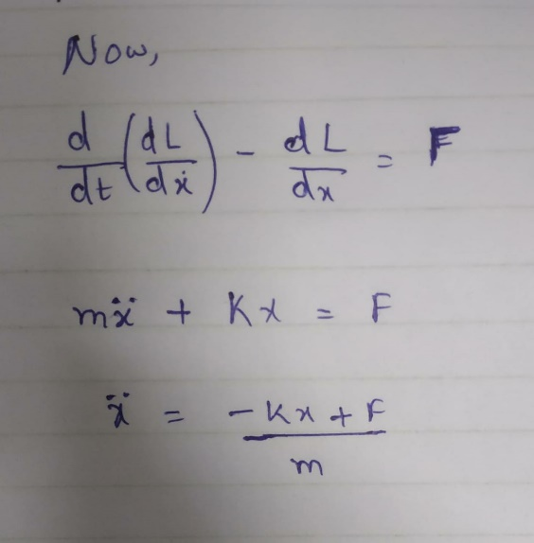

Q4) Is the mass spring system a linear system or non-linear? Justify your answer. (1)

Ans.) The mass spring system is a linear system. This is because the equation of motion is a second-order linear ordinary differential equation with constant coefficients.

Q5) Can the mass spring system be driven to arbitrary state (0.8, 0) using pole placement controller? (Assuming 0.8 is the position and 0 is the velocity). (1)

Ans.)Yes the spring system can be driven to arbitrary state (0.8, 0) using pole placement controller.

**Section 3 - Simple Pulley**

Q6) Under what conditions, will the system remain perfectly at rest? Justify your answer. (1)

Ans.) The system will be at rest when the force from the torque and the pull from m1 balances the pull of m2.

Q7) How many equilibrium points does the system have? Are they stable or unstable? Justify your answer. (2)

Ans.) The system has Zero equilibrium points. This is because the equation of motion has no constant solution.

**Section 4 - Complex Pulley**

Q8) Derive the equations of motion for the complex pulley system. (5)

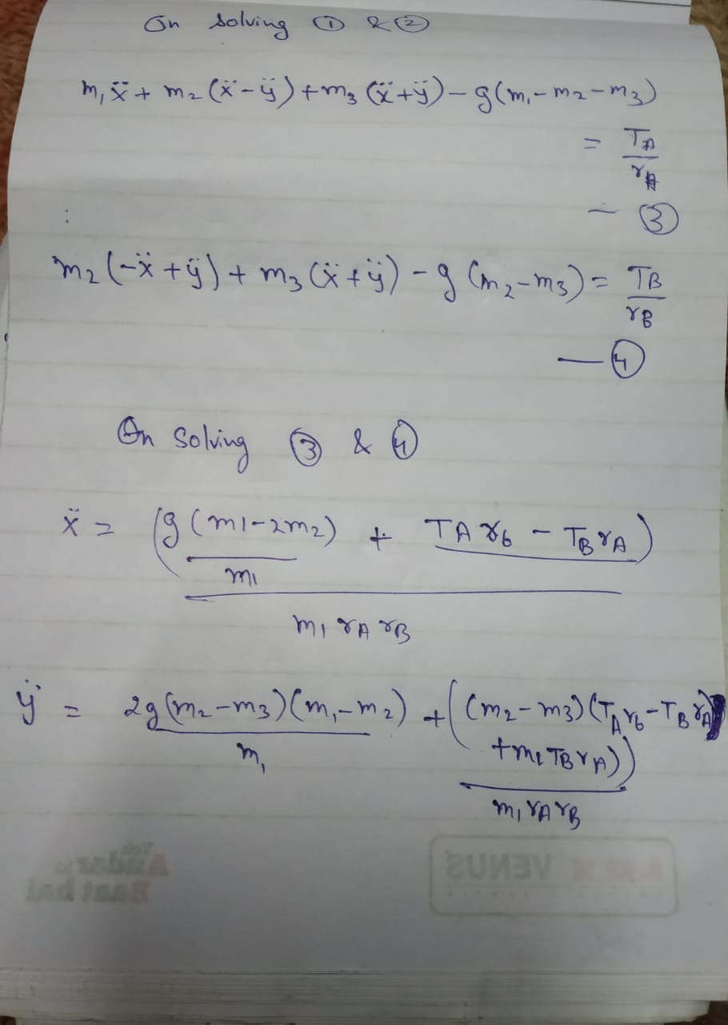Ans.)

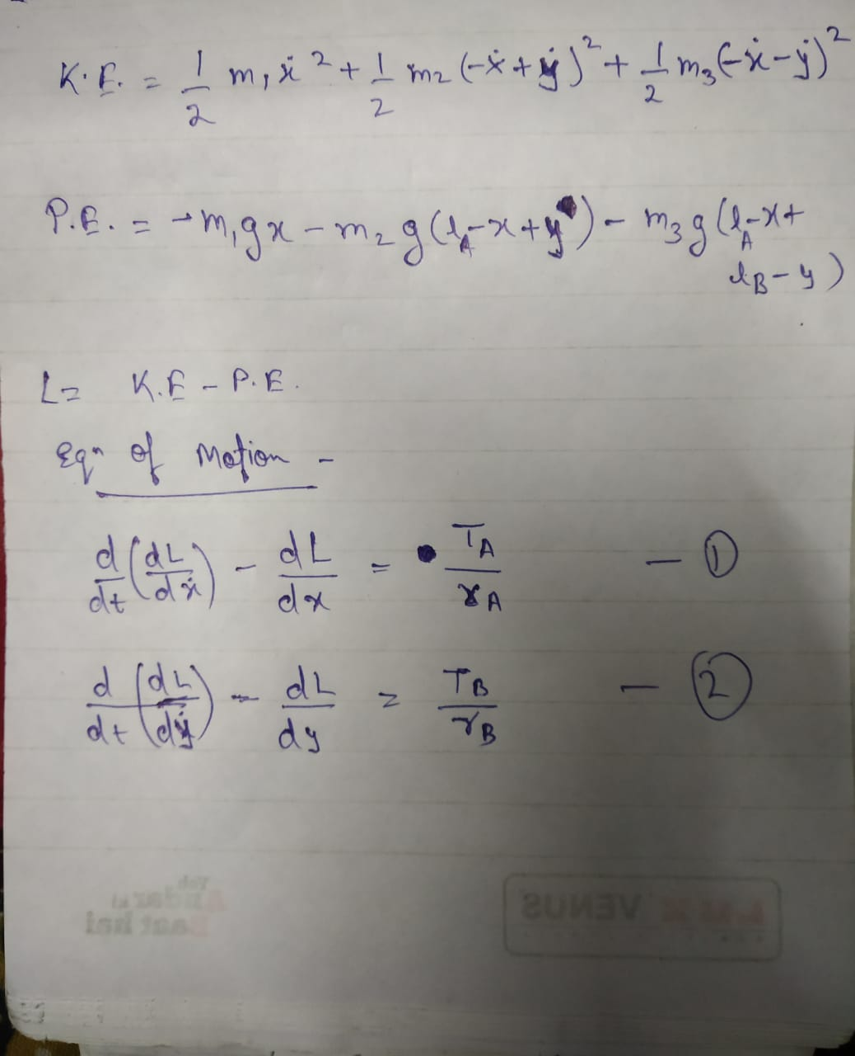

Q9) Derive the A and B matrices for the complex pulley system. Is the system linear or non linear? (4)

Ans.)

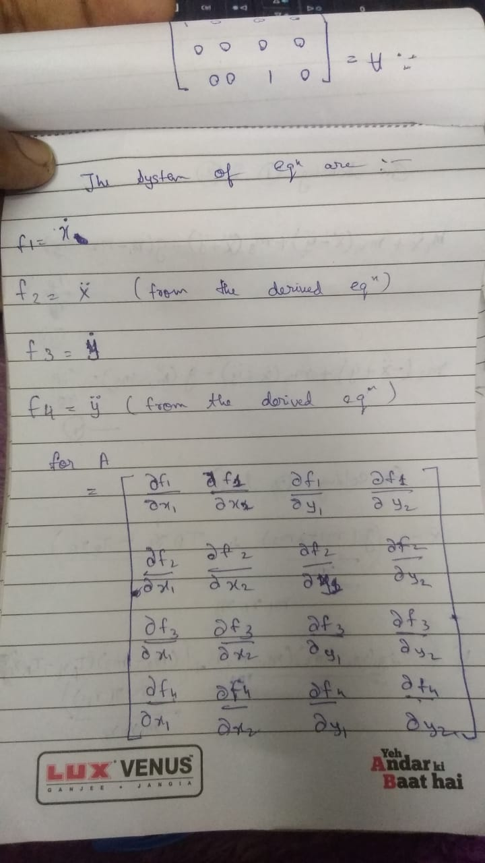

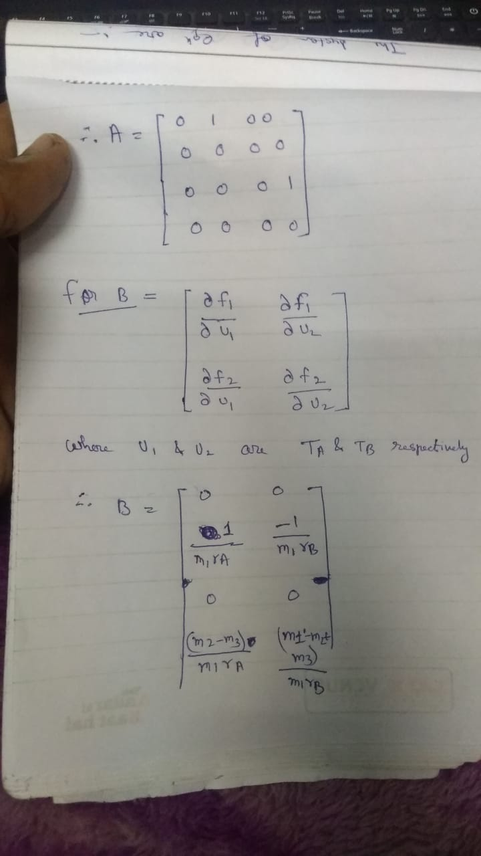

The System is linear.

Q10) Under what conditions, will the system remain perfectly at rest? Justify your answer. (3)

Ans.) We have to consider two condition for the system to remain perfectly at rest.

* The pull for m3 and force produced from torque in pulley B should balance the pull of m2.
* The pull of m3 and m2 combined and force produced from torque in pulley A should balance the pull of m1.

**Section 5 - Inverted Cart Pendulum**

Q11) Derive the equations of motion for the inverted cart pendulum system. Is this system linear or non-linear? Why? (7)

Ans.)

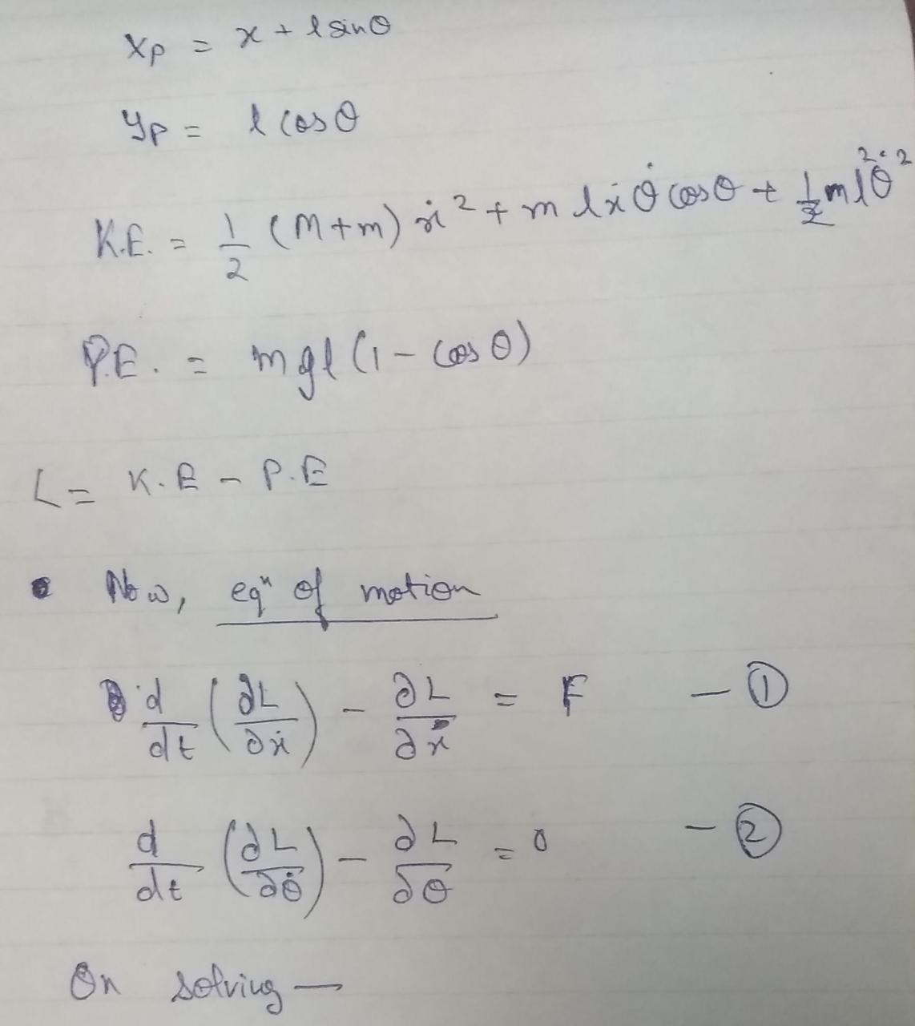

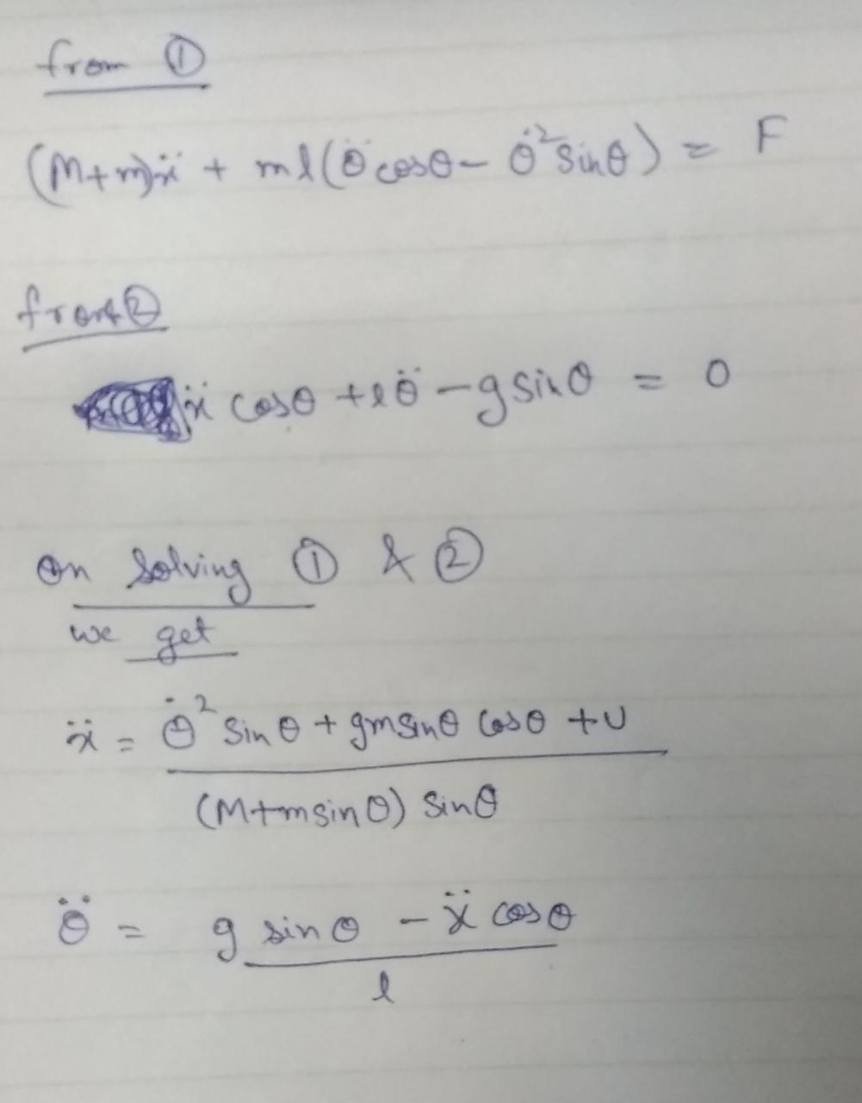

The system is linear because the equation of motion is a second-order linear ordinary differential equation.

Q12) How many equilibrium points does the inverted cart pendulum system have? Categorize them as stable or unstable? (3)

Ans.) The inverted cart pendulum system have two equilibrium points.

* (0,0) which is stable.
* (0, $π$) which is unstable.